Hiện thực 2 Bài tập cộng điểm (điểm cộng tối đa là 5 điểm cho Progress Test)- Hai bài có thể tạo chung Solution ExercisePRN221_StudentNameStudentCode- SQL Script có sẵn, có thể dùng cách tiếp cận Database First/Code First  
- Bài thực hiện xong Submit LMS

- Không được copy bài.

Problem 01. ASP.NET Core Razor Pages with ADO.NET/Entity Framework CoreCreate an application using ASP.NET Core Razor Pages with .NET Core, C#, and ADO.NET (or Entity  
Framework Core). A MS SQL Server database will be created to persist the data and it will be used for reading and managing data.  
Note:  
- You are not allow to connect direct to database from Razor Pages, every database connection must beused with Repository and Data Access Objects.- The connection string must get from appsettings.json file.

A part of CandidateManagement database.  
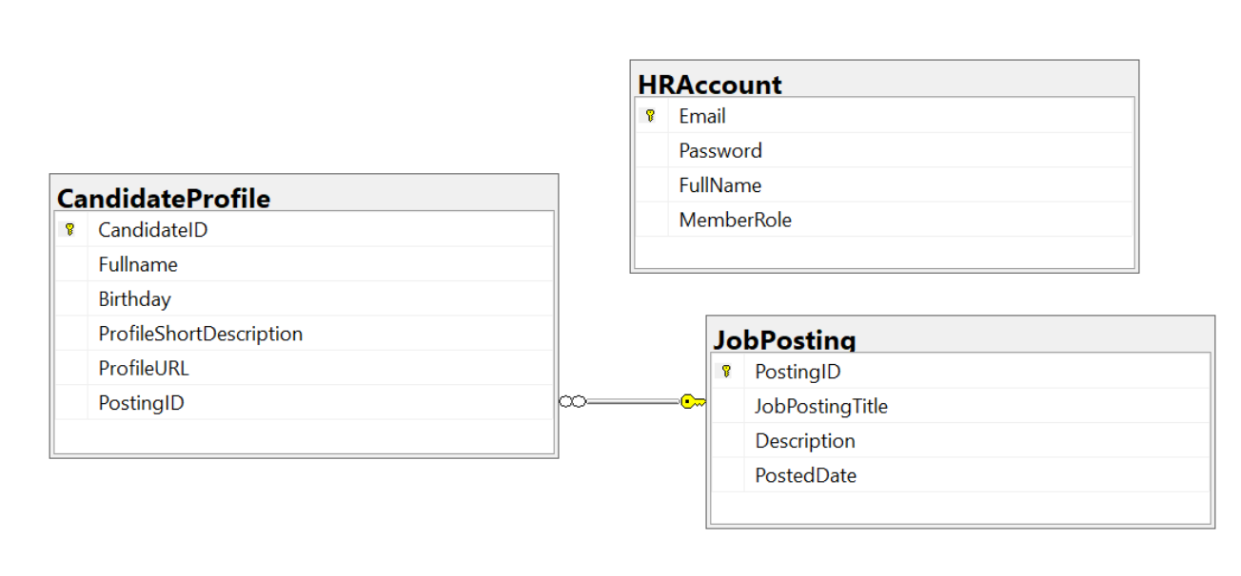

Account role: Administrator = 1; Manager = 2; Staff = 3

1. Authentication function

If user with an administrator role logs in successfully, save this information to a temporary parameter. All  
CRUD actions are required with authentication. In the case login unsuccessfully, display “You are not allowed to access this function!”

2. Check if login successfully, list all candidate profiles in CandidateProfile table (paging is required for this function).  
3. Check if login successfully, search all candidate profiles with 2 conditions: Full Name, Profile ShortDescription (OR option for this case).

4. Check if login successfully, delete the selected item with the confirmation then update the list of candidate profiles.  
5. Check if login successfully, add new item with the requirements:

- The PostingID/JobPostingTitle will come from the JobPosting table (you can use ComboBox UI  
control in this case)

- All fields are required.

- Value for ProfileDescription from 12 – 200 characters.

- Value for candidate’s FullName is greater than 12 characters. Each word of the candidate Fullname must  
begin with the capital letter.

6. Check if login successfully, update an existing item.

- With update function, the same validation requirements with Add function.

Problem 02. SignalR with ADO.NET/Entity Framework CoreCreate an application using SignalR with .NET Core, C#, and ADO.NET (or Entity Framework Core).  
A MS SQL Server database will be created to persist the data and it will be used for reading and managing data.  
- You are not allow to connect direct to database from Worker Service, every database connection must beused with Repository and Data Access Objects.- The connection string must get from appsettings.json file.Add Hub for Real time communication.  
A part of CandidateManagement database.  


Account role: Administrator = 1; Manager = 2; Staff = 3

Account role: Administrator = 1; Manager = 2; Staff = 31. Authentication function

If user with a manager role logs in successfully, save this information to a temporary parameter. All CRUD  
actions are required with authentication. In the case login unsuccessfully, display “You are not allowed to dothis function!”.

2. Check if login successfully, list all candidates in CandidateProfile table (pagging is required for this function, 3 records/1page) with SignalR.

3. Check if login successfully, search all candidates with 2 conditions: Fullname, Birthday (OR option for this  
case and using relative search) with SignalR.

4. Check if login successfully, delete the selected item with the confirmation then update the list of candidates  
with SignalR.

5. Check if login successfully, add new item using SignalR with the requirements:- The PostingID/JobPostingTitle will come from the JobPosting table (you can use ComboBox UI  
control in this case)

- All fields are required.

- Value for ProfileDescription from 12 – 200 characters.

- Value for candidate’s FullName is greater than 12 characters. Each word of the candidate Fullname must  
begin with the capital letter.

6. Check if login successfully, update the selected existing item with SignalR.  
- With update function, the same validation requirements with Add function.